**Flow of project:**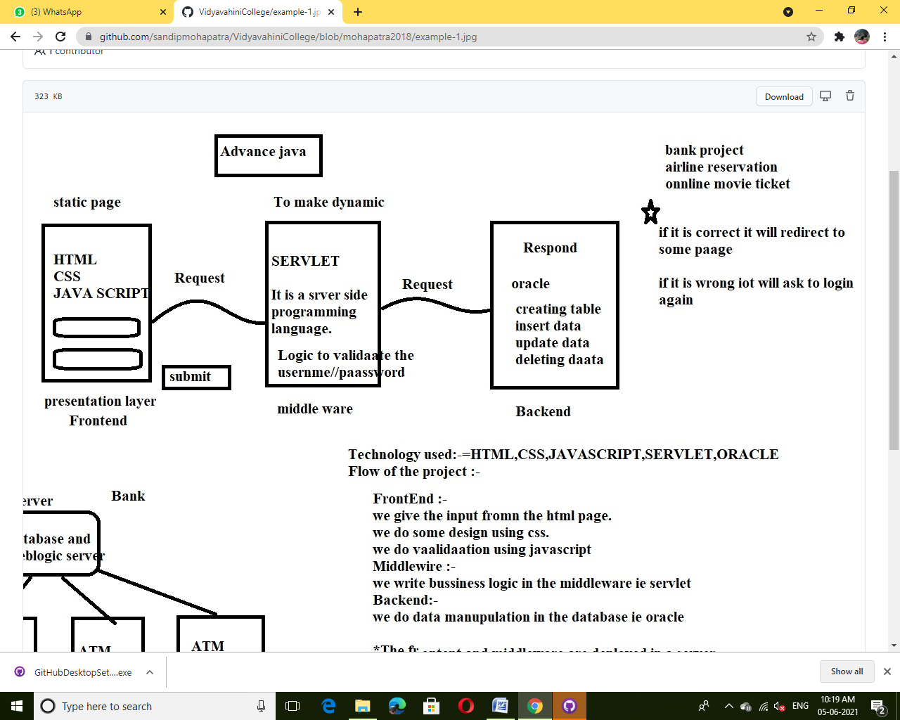

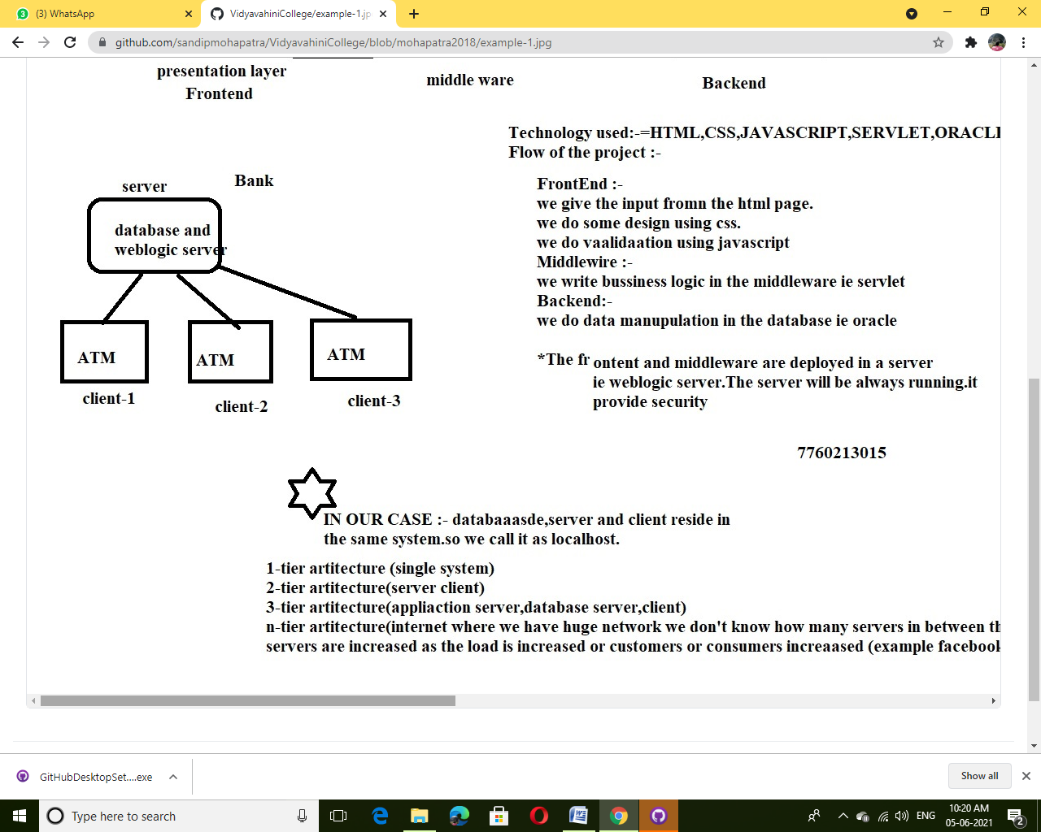

**Tier Architecture:**

## Types of DBMS Architecture

There are mainly three types of DBMS architecture:

* One Tier Architecture (Single Tier Architecture)
* Two Tier Architecture
* Three Tier Architecture
* N Tier Architecture

## 1-Tier Architecture

**1 Tier Architecture** in DBMS is the simplest architecture of Database in which the client, server, and Database all reside on the same machine. A simple one tier architecture example would be anytime you install a Database in your system and access it to practice SQL queries. But such architecture is rarely used in production.

[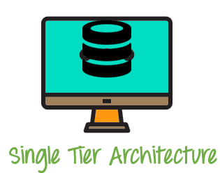](https://www.guru99.com/images/1/091318_0745_DBMSArchite1.png)

**2-Tier Architecture**

A **2 Tier Architecture** in DBMS is a Database architecture where the presentation layer runs on a client (PC, Mobile, Tablet, etc.), and data is stored on a server called the second tier. Two tier architecture provides added security to the DBMS as it is not exposed to the end-user directly. It also provides direct and faster communication.

[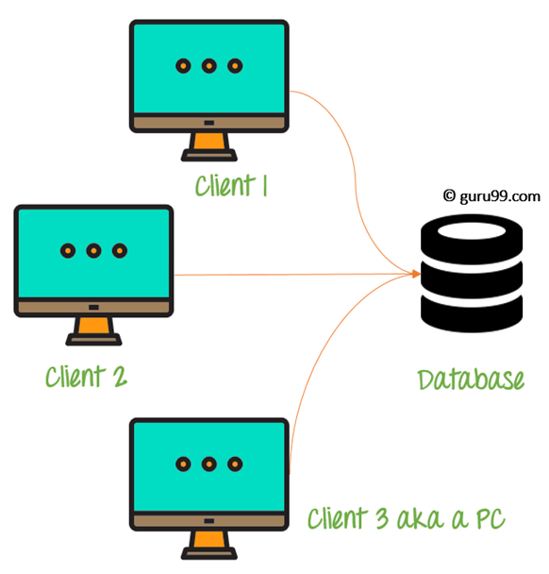](https://www.guru99.com/images/1/091318_0745_DBMSArchite2.png)

2 Tier Architecture Diagram

**3-Tier Architecture**

A **3 Tier Architecture** in DBMS is the most popular client server architecture in DBMS in which the development and maintenance of functional processes, logic, data access, data storage, and user interface is done independently as separate modules. Three Tier architecture contains a presentation layer, an application layer, and a database server.3-Tier database Architecture design is an extension of the 2-tier client-server architecture. A 3-tier architecture has the following layers:

1. Presentation layer (your PC, Tablet, Mobile, etc.)
2. Application layer (server)
3. Database Server

[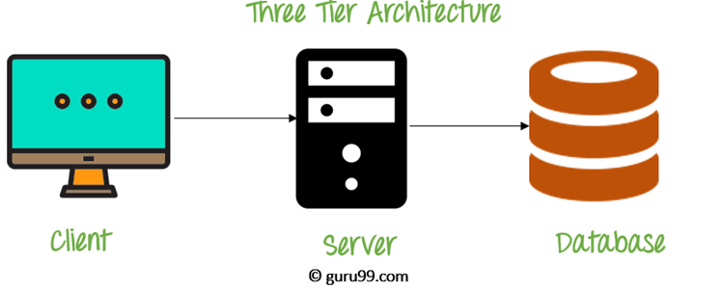](https://www.guru99.com/images/1/091318_0745_DBMSArchite3.png)

3 Tier Architecture Diagram

**N-Tier Architecture**

N-tier architecture would involve dividing an application into [three different tiers](https://msdn.microsoft.com/en-us/library/bb384398.aspx).  These would be the

1. logic tier,
2. the presentation tier, and
3. the data tier.

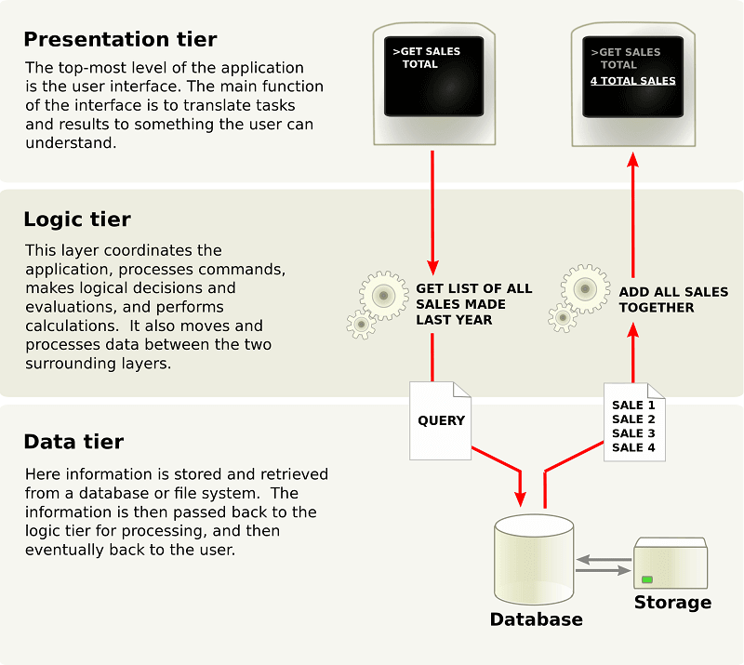

**SYSTEM REQUIREMENTS:**

1. **Oracle Software**
2. **Eclipse Software**
3. **Platform811 Software**

**Installation of Oracle Software:**

Step1: download the oracle software

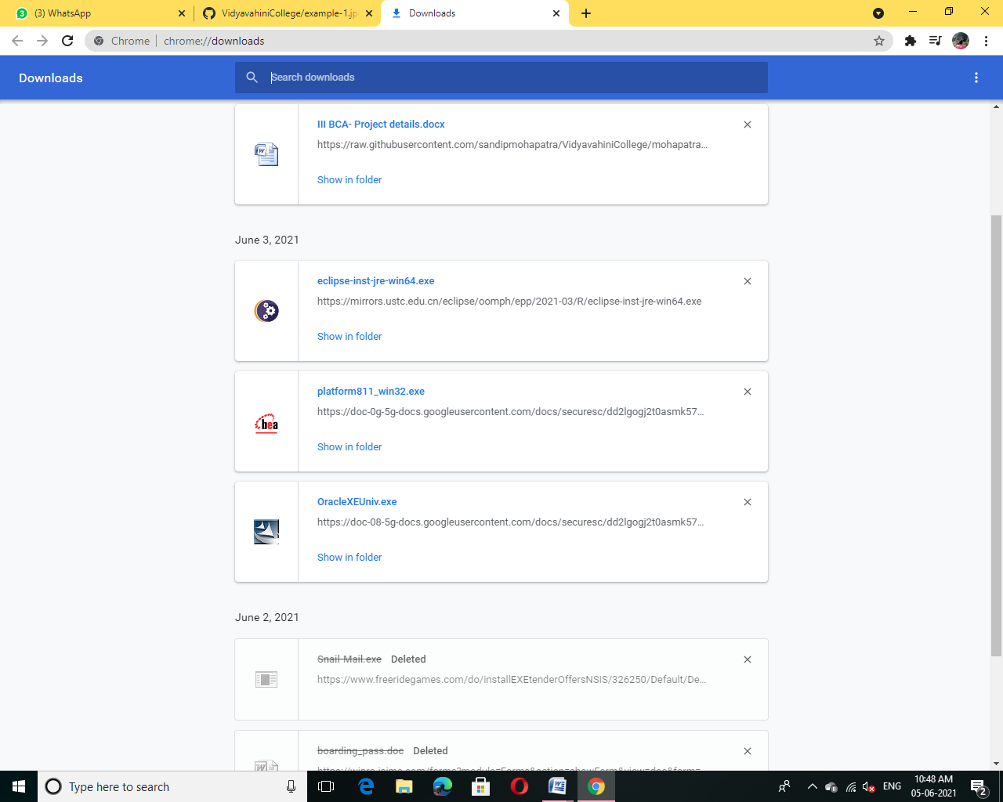

Step2: Install the oracle software

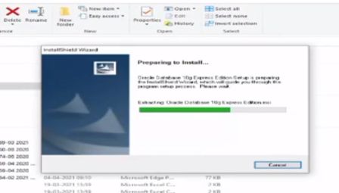

Step3:After installation select I agree then click Next

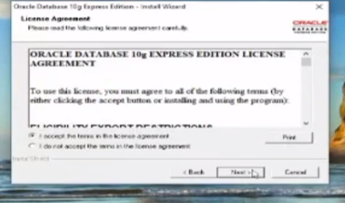

Step4:After that click Next Button again

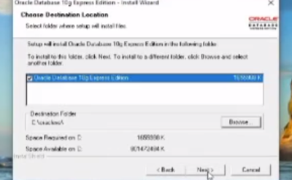

Step5:After step4 set password as 1234 and then click Next button

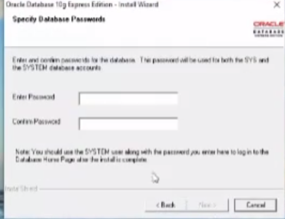

Step6:And then click Install Button

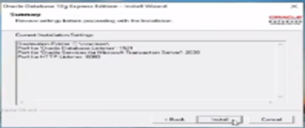

Step7:Installation process

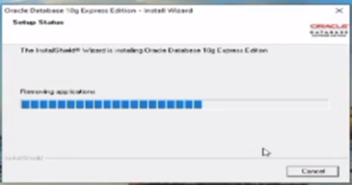

Step8:The installation is done click Finish button

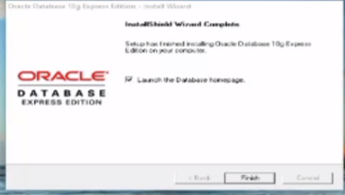

Step9:After step8 it takes to login page:

Use Username as System and password as 1234

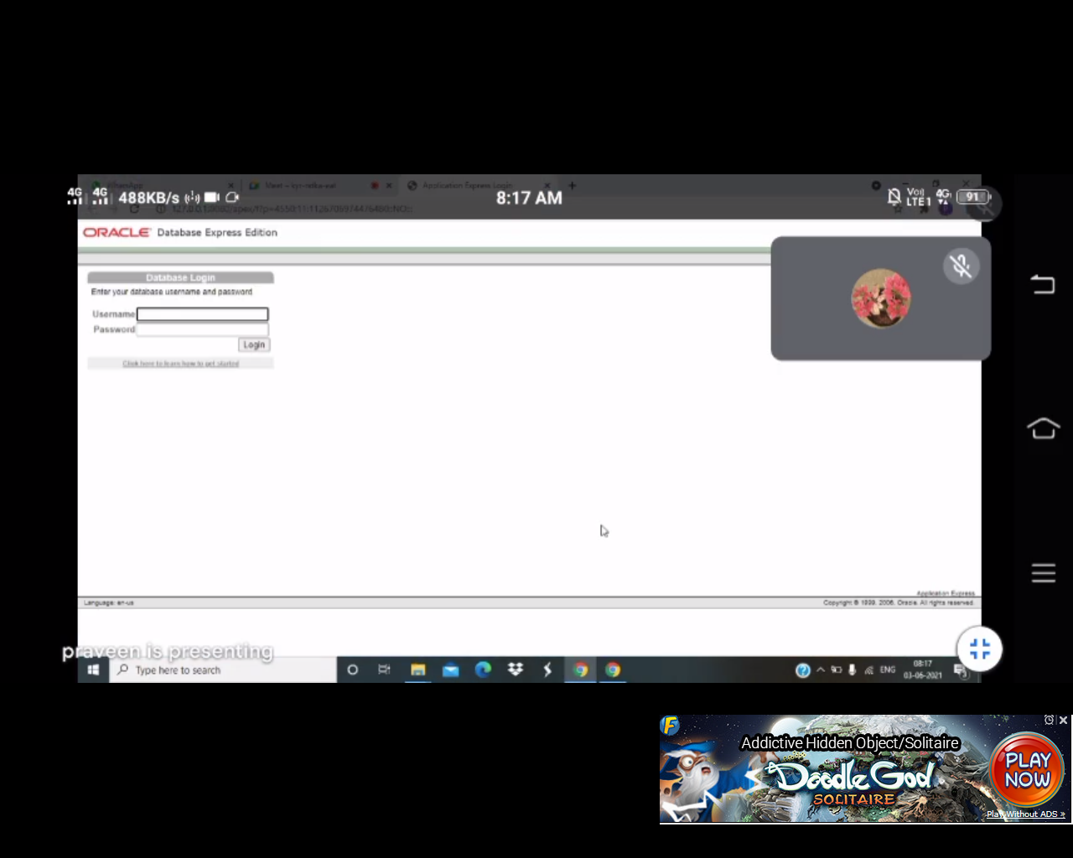

Step10:After login select SQL

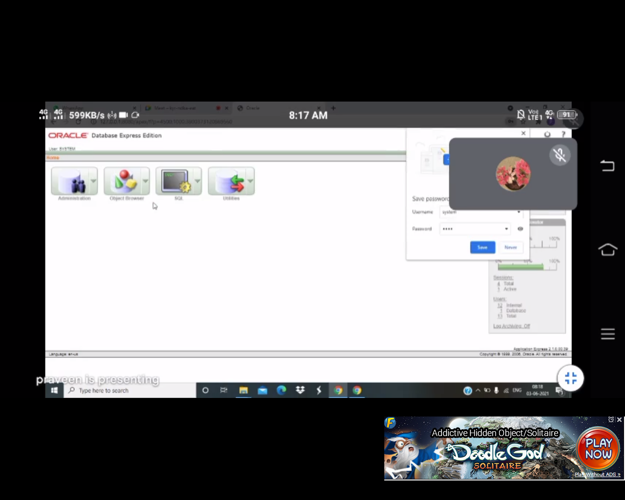

Step11:After selecting SQL click on SQL Command

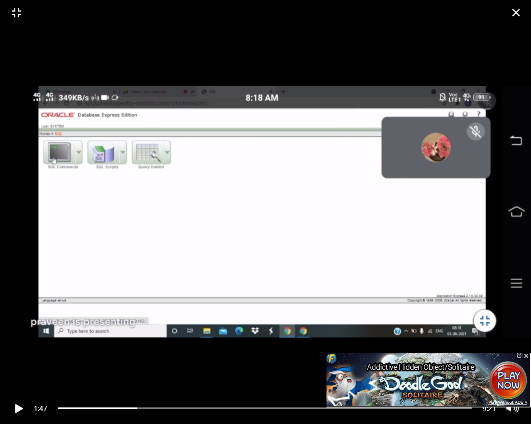

Step12:After Selecting SQL Command we can create table here

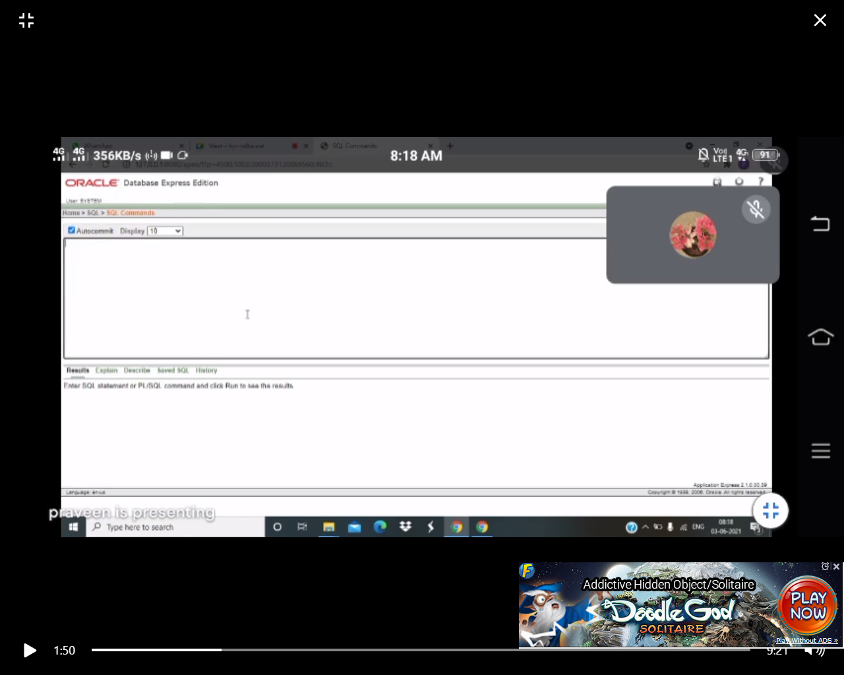

**Installation of Eclipse Software:**